Jenkins:  
Maven:  
Sonar-Nexus:  
Tomcat:

Jenkins:

Git Clone:  
Source code mgmt.:  
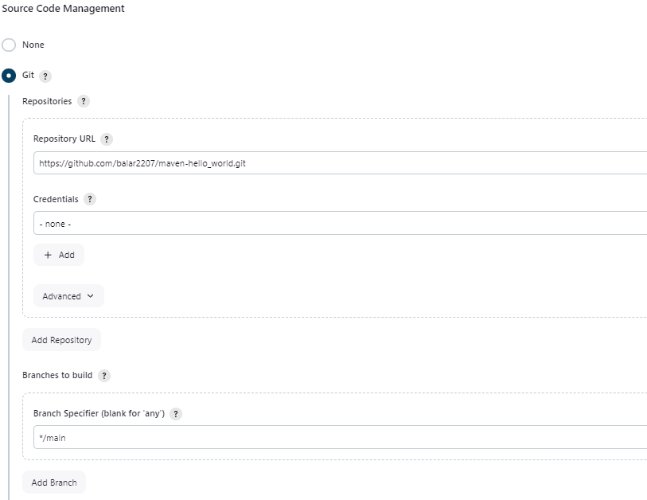

Maven:

Plugin:

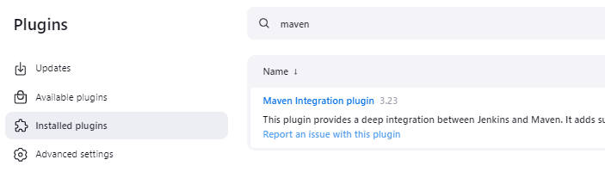

Tools:

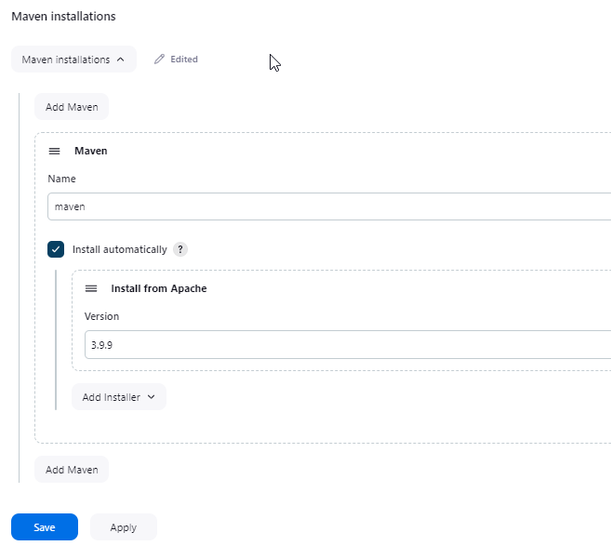

Source code mgmt.:  


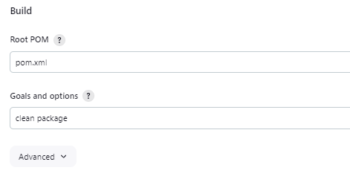

Sonar:

Plugin  
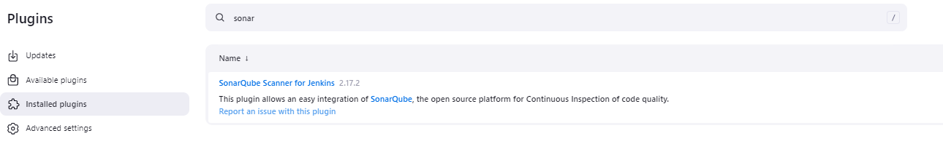

Credentials:  
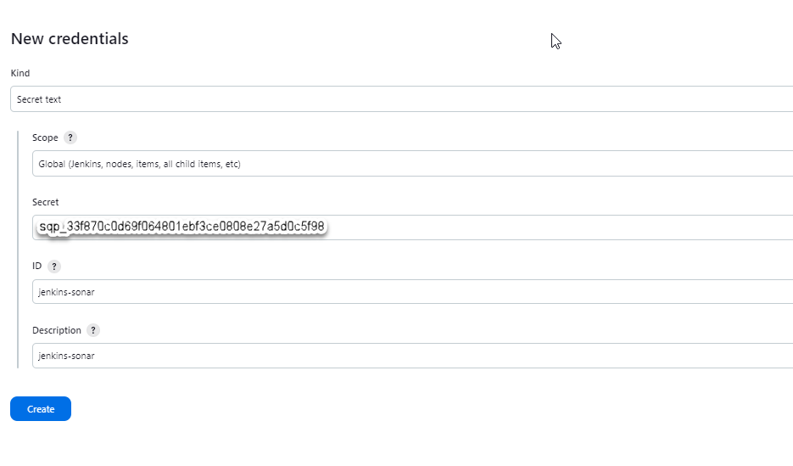

Tools:  
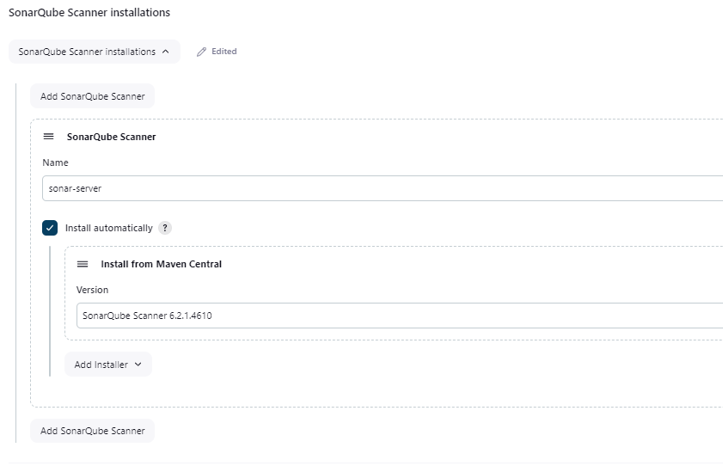

System:  
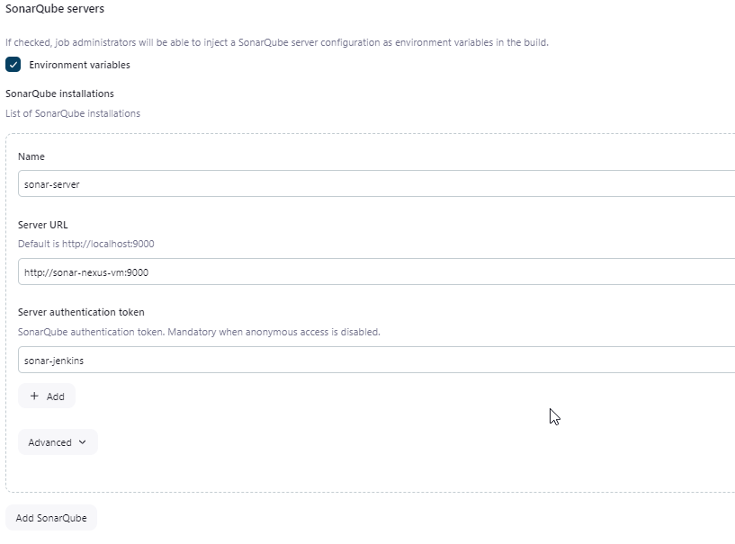

Jenkins Job create :

Source code mgmt.:  


Pre and post build:  
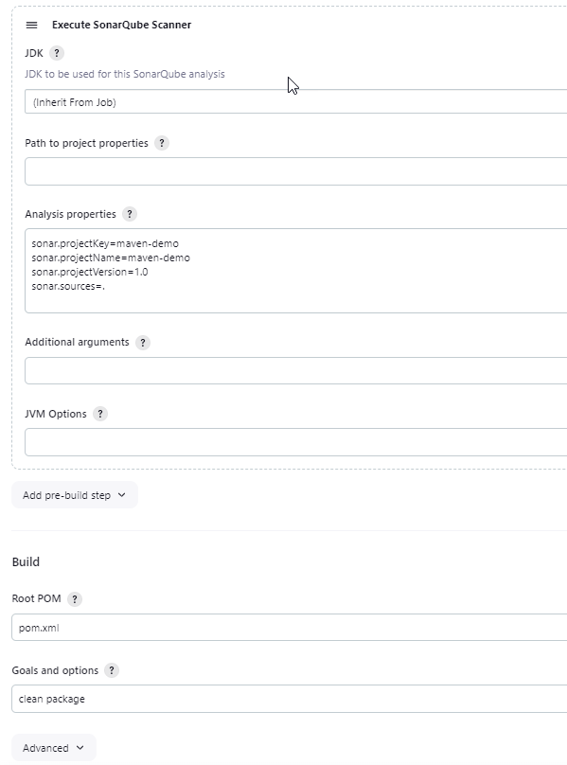

Build output: successful

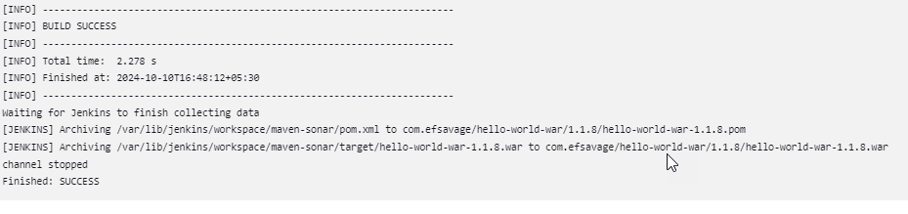

Nexus:  
Plugin:  
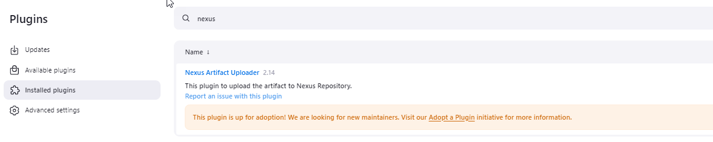

Credentials:  
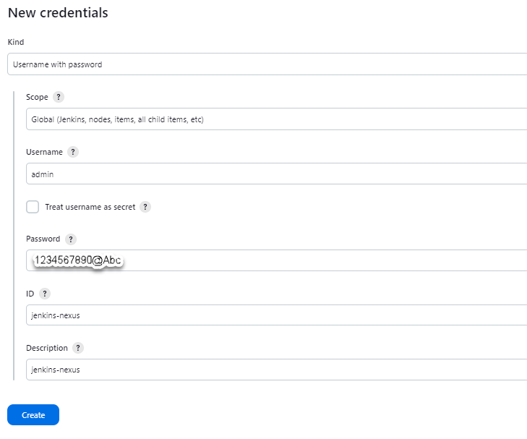

Pre and post build:  


Source code mgmt.:  


Build:  


Post steps:  
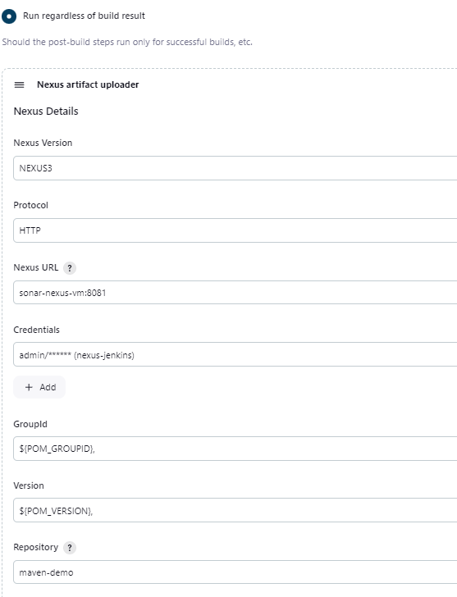

Artifact:  
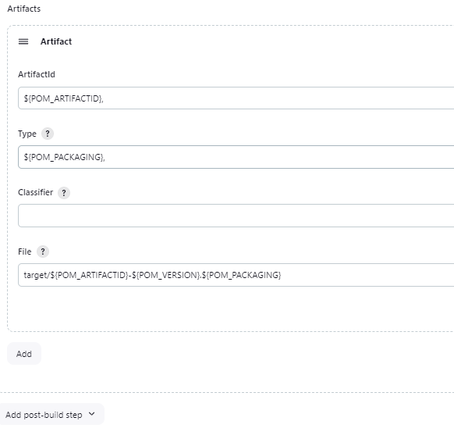

Build Successful:  
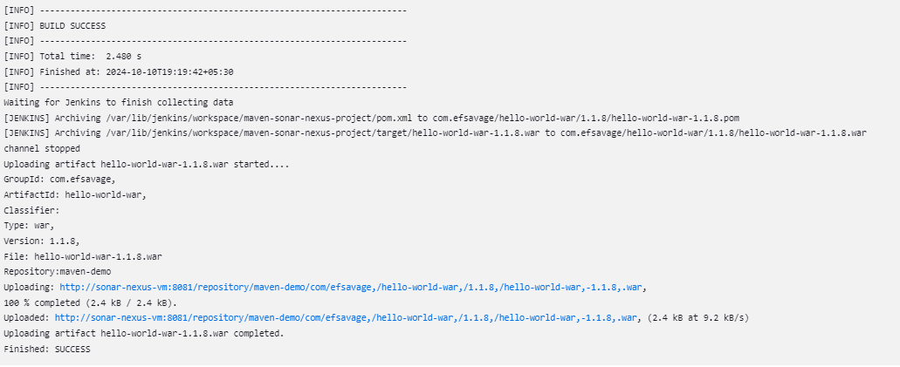

Tomcat:  
Plugins:  
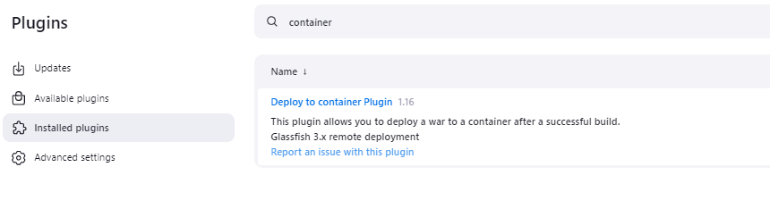

Credentials:  
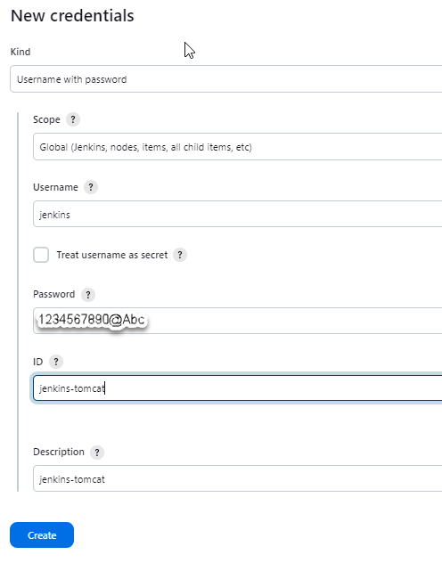

Pre and post build:  


Source code mgmt.:  


Build:  


Post steps:  


Artifact:  


Post Build Actions.:  
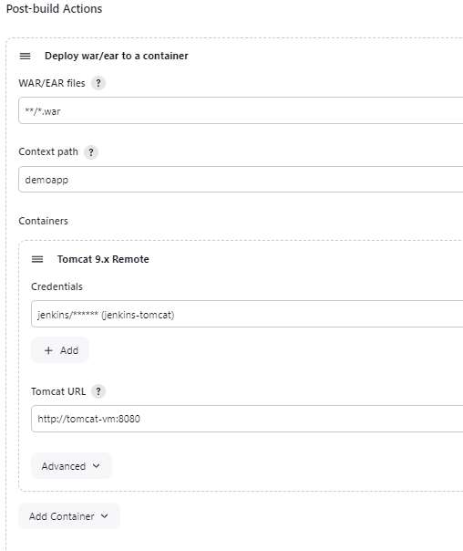

Build Success:  
